Cary Kaczowka
PDI Studio V
Assignment 6 – Response Device

For our group’s response device, we decided to play off of an idea that started out as creating food or goodies with fractions. The students we are looking to work with, 6th graders, are learning math that deals with fractions and they already have some understanding of how they work.
Our other inspiration was SandArt, a popular craft where children pour layers of sand into clear containers to create their own works. We hoped to bring our own version of sand art (containers of colored salt) and bottles (emptied Hawaiian punch containers) for the kids to work with.
Because we worked with a few different groups of students, we were able to try out various techniques with each. With one group we planned to let them create openly, without structured prompts. With the second group we asked them to divide the bottle into tenths and fill with sand accordingly. For the final group we asked students to work in pairs to create a bottle for each student to take home.

Hypothesis:
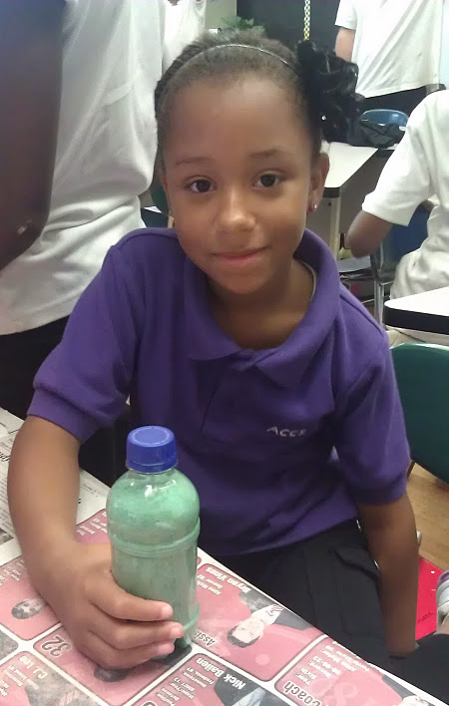
I hypothesized that the kids who were given less guidance would create sand art that was similarly less structured. There would be more kids who were tempted to mix all the colors and create a brown blob (this was a pattern I had noticed as a kid doing arts and crafts). I anticipated a gender difference, where girls may be more patient and willing to plan out a design rather than simply pour large layers of color. I anticipated the boys would be more likely to shake the sand up because they enjoyed the physical activity. When the kids worked to divide their bottles into tenths, I imagined that they would need a little bit of assistance but should know how to determine what fraction of the bottle was a tenth, and then have little trouble. And finally when we asked the kids to work in pairs, I anticipated that there may be some arguments over the best method for pouring and layering; they would not enjoy this method as much.

Observations:
Group 1, the group given an unstructured prompt, did seem to enjoy making their bottles. They happily looked around the table for more colors, and were asking each other for colors to share. Some kids were a bit less patient than others and wanted a bigger spoon to fill the funnel with sand faster. One boy tended to shake his sand up more than others along the way.

The girl pictured to the right filled her container with a lot of blue material, and asked for white. When she was asked why she was mixing it all up, she said that she had a lot of blue sand and wanted to make it a lighter blue by adding white. From this, and a few other encounters, we have gathered that the students have a very good understanding of what color mixing should create.

Additionally, I asked one girl what proportion she thought each color took up in the jar, and she thought there were twelve colors each taking about 15% of the volume. Although I gently explained how this would result in more sand than the jar could hold, I really was left with the impression that not all of these students fully understood percentages.

Group 2 faced some different challenges when they were asked to fill the bottle in tenths. Many students asked for a lot of help to mark where tenths would land on bottles, but had trouble doing that without help from us. Giving them this structure, however, led them to create sand art that had more structure and distinguished colors, which they seemed happy with.

The last group, which was asked to work in pairs, had an interesting time making the artwork. One pair seemed to work smoothly together, and agreed to make one student’s first, and then the other’s. When asked they thought it would not be hard to make this project with someone who isn’t a friend. Eventually this team split up so one student could add some finishing touches while the other continued to create the second project.

While these boys were working together, another pair were working together and planning what they wanted ahead of time. These boys did not get along well in general, and while working together one said, “I hope you’re not wasting my time.” Despite any unfriendliness they worked to develop a project they both cared about. From this I think the type of project we asked the kids to create is not necessarily improved through group work, but it can be equally effective.

Finally, two girls were not able to make their own sand creations during class time and asked us to stay behind and work with them to make some. This makes me believe that this project was very successful because of its interactive components and the ability for students to take creations home to share.

I agree, this was a great project! I especially liked the way you explored the mechanics of sand mixing with the kids’ understanding of math. Writing gave a nice account of the behavior and comments. Grade = A.

