Cary Kaczowka
November 2, 2011
Ethnography: Third trip to ACCS

On this third trip to visit the 6th grade students at ACCS, our group brought along both a PowerPoint and a hands-on version of the color-mixing flash game that we intend to create. The PowerPoint (see a screenshot below) illustrated the basic structure of the game (main page, landing page, color mixing…).
We showed each group of students the PowerPoint, giving them an idea of the game’s play. The main comment the kids had, besides thinking the PowerPoint animation was cool, was that the paint splat should be the same color as the color they just created, not just a generic color. (In the background you can see that the goal of this slide was to create orange yellow, not purple.) Another student understood the paint splat to be bad, although we intended it to be a positive message.
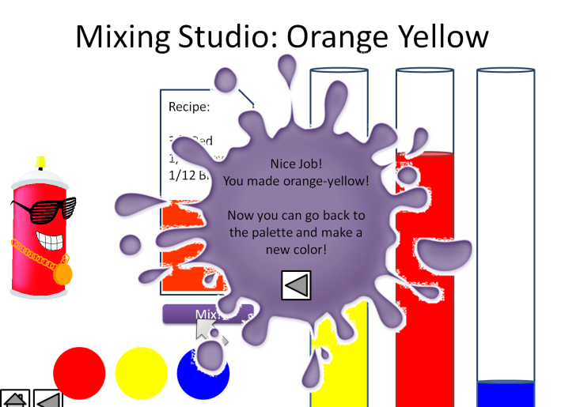
When we moved to the end of the PowerPoint, the students were shown three characters that Paula and Pat created. The first two characters were not well-received. Students did not like Spray Can Steve, and commented that his clothes did not match. The third character, however, went over very well. (See the red spray can.) Kids liked his glasses and chain, and the overall style. We asked students to suggest some modifications to his outfit, and suggestions included: bigger glasses, gold teeth, dreads. We asked some students to draw their own characters, and they came up with a number of different ideas. Many of them were multicolored and had characteristics that we were trying to avoid, afraid of focusing on cultural stereotypes.
They wanted to name the last spray can character an assortment of names, including T-Paint.
When we moved on to the hands-on activity, we were asking the students to follow a recipe to create a color. There are three beaker-type images, with ruler markings that divide it into twelve sections. The kids had a pile of colored plastic rectangles that were a variety of sizes. In order to complete the recipe, they needed to cover one beaker with the corresponding fraction of each color. We would check their fractions and determine if they were correct.
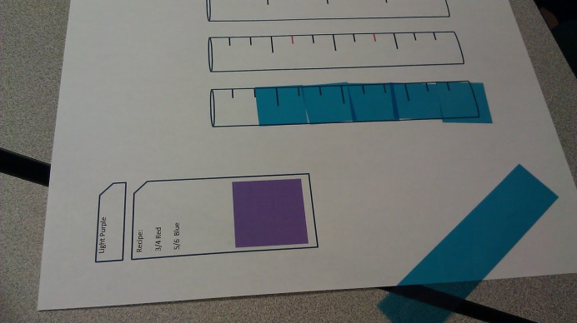
When working with the students, most understood the concept of fractions easily, but creating equal fractions with a denominator of 12 (for the twelve sections) was more difficult. Many students needed assistance finding the equivalent fraction of 5/6, meaning 10/12. With some assistance they were all able to understand and properly fill each fraction.
With different groups we decided to try different strategies. The first group competed in pairs, as a race. When a student successfully completed a recipe, they were allowed to play their turn in a tic-tac-toe game. This element of competition seemed to make the game far more enjoyable than simply completing a recipe. With the third group, boys and girls were on opposite sides of the table, and the girls worked together on one recipe while the boys tried to beat them. Again, this appeared to make the game more fun, as they tried to compete in the tic-tac-toe game. A fourth group had only a few students, and instead of racing each other with fractions, students were challenging us to a race. This also worked out to be very fun. The kids occasionally beat the RPI students.
One big take away from this visit is the factor of competition. I believe it’s a major factor in making the game successful. Additionally, although it appears fractions are a common theme among student groups, the professor enjoyed our hands-on activity because it gave students a chance to really visualize what the numbers mean and hopefully understand it much better

